Adding Users into Microsoft Intune
1. Open the Microsoft Intune portal by clicking the link in the email that you received from creating your subscription in Exercise 6.1.
2. Once you’re in the Intune Dashboard, click the Users link under Management.
3. In the center of the console under Users, you will see a New button with a down arrow. Click New and choose User (shown in Figure 6.4).
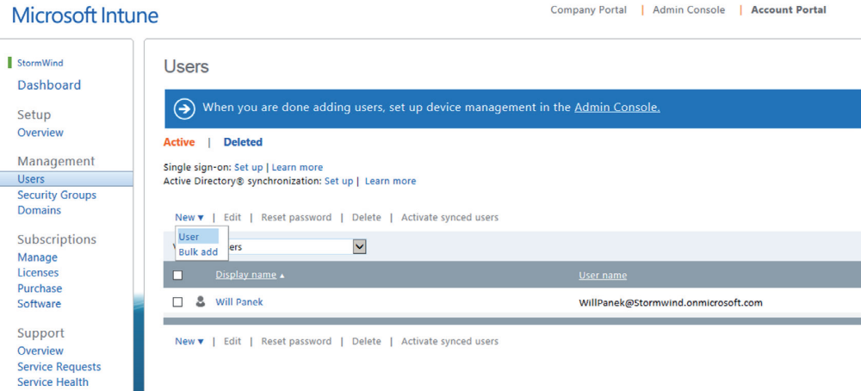
4. If you are asked to re-log back in, enter your Intune username and password.
5. On the New User Details screen, enter the user’s First Name, Last Name, Display Name, and Username (see Figure 6.5). Click Next.
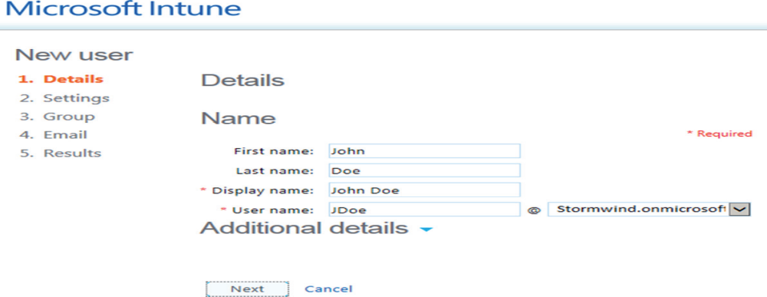
6. On the Assign Role screen, you must decide if this new user should have administrative
rights and which type. You can choose Yes or No on this step. (I chose Yes, gave the user global administrator privileges, and set up an email address for administrative emails.) Click Next.
7. At the Group screen, just click Next. You will add users to a group in another exercise.
8. At the Send Results In An Email screen, make sure there is an email address for this
user and click Create.
9. At the Results screen, print out the user’s temporary password (see Figure 6.6). Click
Finish.
